Briana Harrold
Kernsville Elementary School

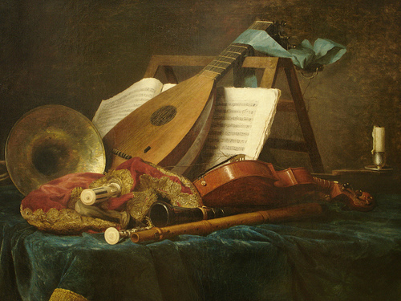

Enduring Idea: Throughout time and across cultures artists have used attributes to portray individuality in their subjects.
Lesson Title: Attribute Shelf
Grade: Fourth
Time Allotment: 2 or 3 classes

Overview

Lesson Summary: Students will create a work full of personal imagery in this project. They will learn what personal imagery and attributes are and how artists have used this concept in the past. They will be given a worksheet that will organize thoughts about themselves. The worksheet will ask them a variety of questions regarding their interests and how they describe themselves. From this they will come up with thumbnail images that match up to these hobbies and qualities. They will be asked to choose at least three of those images for their final. They will do a rough draft on precut elongated paper. They will be asked to create a shelf at the bottom of the page. They will have options at what to do, for example, a wooden shelf, a glass shelf and others. They will then arrange their images as objects on a shelf. After their rough draft is approved, they will move on to a final piece. Colored pencils will be recommended but outlines may be done in marker.

Artwork and Artists: Works by…
Aleksandr Platonychev
Jean-Baptiste-Siméon Chardin
Anne Vallayer- Coster

Key Concepts: Images can give clues to personality traits.
Objects can be helpful in understanding what a person enjoys.
Imagery has been used throughout the ages.
Imagery is related to symbolism.
Attributes are used to describe a subject.

Essential Questions: How can you describe yourself through imagery?
How would you describe yourself?
How have artists in the past used symbolism and imagery?
How are symbolism and imagery different?
How are imagery and symbolism similar?
What does the word attribute mean?

Standards:
9.1.3.A: Know and use the elements and principles of each art form to create works in the arts and humanities.
9.1.3.C: Recognize and use fundamental vocabulary within each of the arts forms.
9.1.3.E: Demonstrate the ability to define objects, express emotions, illustrate an action or relate an experience through creation of works in the arts.
9.2.3.D: Analyze a work of art from its historical and cultural perspective.
9.3.3.F: Know how to recognize and identify similar and different characteristics among works in the arts

Interdisciplinary Connections:
R3.A.1.1: Identify and interpret the meaning of vocabulary.

Objectives: Students will…

Knowledge- Students will define the meaning of an attribute literally and visually.
Students will analyze themselves by completing the worksheet.
Skills- Students will design and develop their own creative composition.
Students will employ craftsmanship by completing the final draft with care and creativity.
Dispositions- Students will demonstrate responsibility by following given directions.

Performance Task Assessments: Students will be graded on…
Completion of worksheet
Communication of self through attributes
Craftsmanship
Following directions

Sequence of Actions:

Day1- Motivation- After greeting the class I will ask a few questions regarding their knowledge of symbolism and imagery. I will then present historical work that contains bits of personal imagery that gives viewers clues about the subject. This will be in the form of a PowerPoint presentation. I will do a small demo on the set up of their piece.
Development- a worksheet will be given out (attached). Students will complete this worksheet by filling out the questions and drawing thumbnails in the given boxes. If they need more room for thumbnails they can go on the back. Once completed, they may grab a rough draft piece of paper and further organize their thoughts.
Closing- I will announce clean up and for each table to line up they will have to answer a question that had been reviewed in class about attributes, their meaning, and examples.

Day 2-3- Motivation- After a greeting and a brief review of the lesson and demo, students will go back over their work thus far.
Development- Students will continue on their rough draft, get some color organization and proceed to the final piece of paper. There will be reminders of space and size relation among objects. They will proceed through to their final copy. Expected to finish by 3rd day if needed.
Closing- I will announce clean up and for each table to line up they will have to answer a question that had been reviewed in class about attributes, their meaning, and examples.

Teacher Preparations:
Make PowerPoint
Create and make copies of handout
Cut paper
Provide colored pencils, pencils, and erasers
Plan demo

