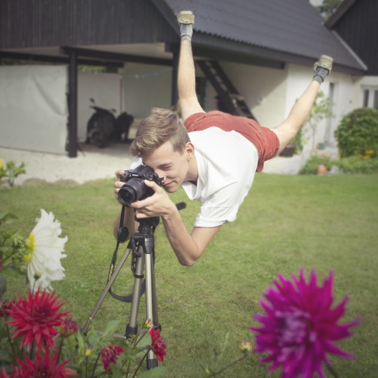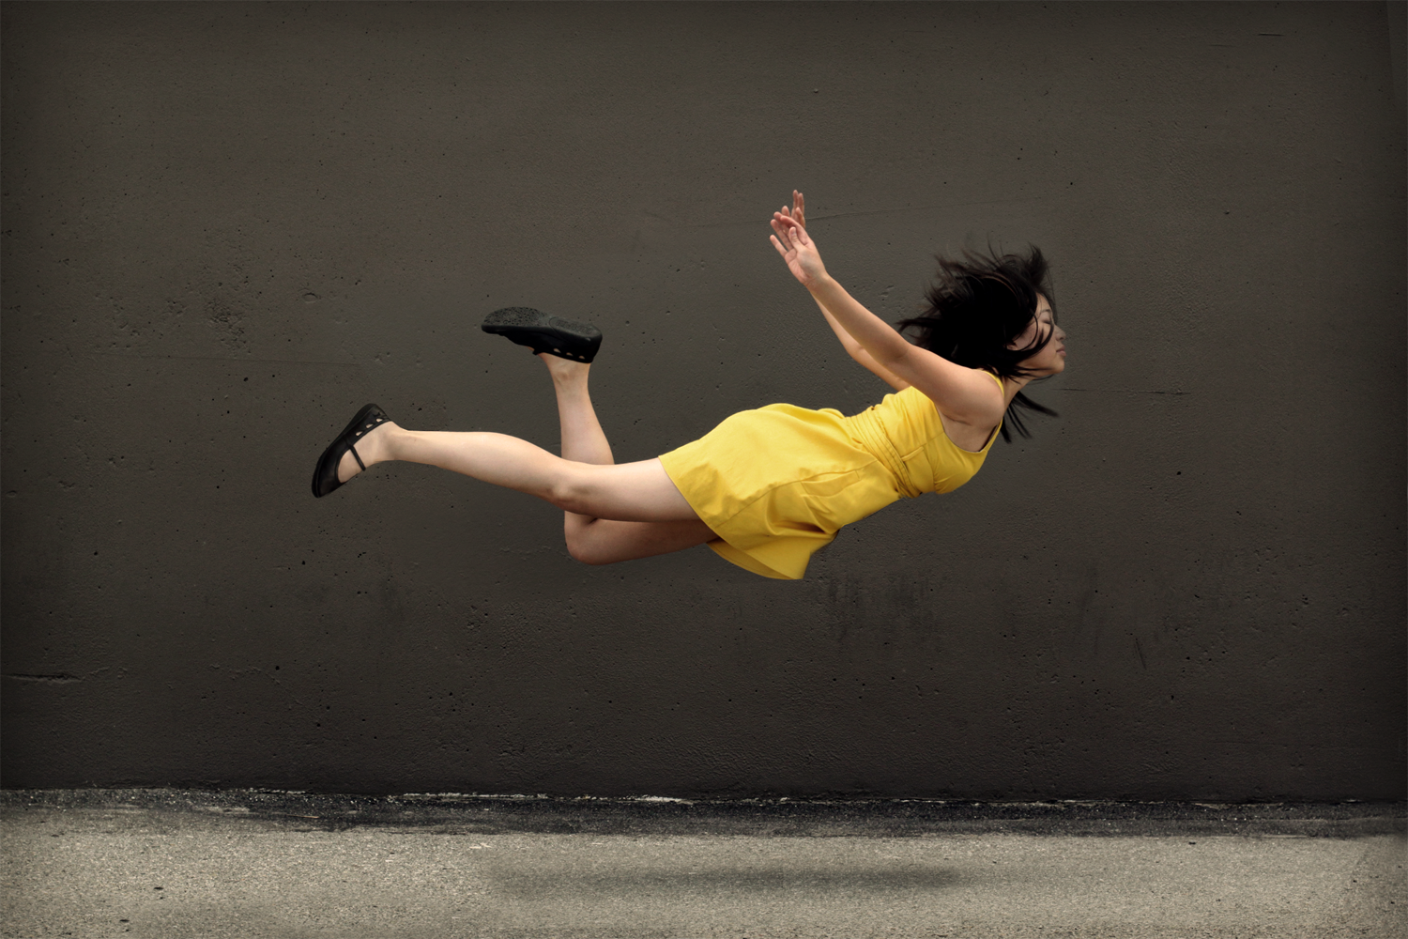

Digital Photography

Levitation

**Essential Questions**

How can I take pictures to benefit me in editing?

How does design come in to play when creating illusion?

What tools and techniques can create the best image?

**Key Concepts**

Illusion is made easy with Photoshop

Masking retains the original image

Directing a shoot is important to capture intended design

Academic Standards

9.1.12.K:

9.1.12.C:

Integrate and apply advanced vocabulary to the arts forms.

Analyze and evaluate the use of traditional and contemporary technologies in furthering knowledge and understanding in the humanities.

Know and use the elements and principles of each art form to create works in the arts and humanities.

9.1.12.A:

**Enduring Idea**: Illusion is very much based around design.

**Grades:** 10-12

**Time Allotment**: 4-5 classes

In this lesson students will be experimenting with illusion by creating a levitation photo of either themselves or a friend. Students will be introduced to new Photoshop techniques through tutorials and other provided resources. The introduction class will include these resources. Students will be given a choice of videos and blogs to do their own research and watch a video as a class. They will have up to two classes to go out and take photos with a group and then there will be at least one class that will include editing demos and one on one assistance. Students will be learning about masking, retaining image files and editing in a way that conserves time and file integrity. They will also use tools such as the quick selection tool and blending modes

## Summary

Photoshop Tools

Masking

Quick Selection Tool

Vector mask

“Black Conceals, White Reveals”

Blending Modes

+

Briana Harrold- Quakertown High School

Black Conceals

and

White Reveals

### Student Objectives and Assessment for Grading

Knowledge:

Students will understand new tools by using them to effectively show craftsmanship

Skills:

Students will design and direct their group to come up with innovative ideas that can be seen in their original photos

Disposition:

Students will display collaborative ideas by coming up with interesting compositions with their group

Learning Targets to be reached:

Visual Composition

Conceptual Innovation

Technique and Craftsmanship

**Day 1-** *Motivation-* After a short greeting students will be asked to not log in to computers yet so that they can come to the viewing area of the room to watch a video. I will begin by giving a quick intro to levitation and what it means exactly. I will talk about illusion and how digital technology can make creating illusion easy and effective. *Development-* I will show some of the references that I put on the share drive. I will point out and repeat the terms I feel are important. Students will be asked to being thinking about composition and planning of a picture. They will be allowed to explore the references and tutorials themselves for inspiration *Closing-* Students will be asked to log out and we will go over any ideas that students may have for the upcoming days

**Day 2-** *Motivation-* After a short greeting I will give a demo of how to use a tripod and explain the importance of using one when taking multiple photos to be used in a single composition. They will be asked to get into groups and then sign out a camera and a tripod and go out and take pictures. *Closing-* Students will come back to the classroom, put all cameras and tripods away. We will go over discoveries, challenges and findings before they are dismissed.

**Day 3-** *Motivation-* After a short greeting we will go over some reminders of what their goal of the day is. Depending on the amount of students that have completed their goals will depend on the amount of time given to take pictures. *Development-* If most need more pictures students will be given 25-30 minutes in the field before they are to return for a Photoshop demo. In this demo I will be showing how to use the quick selection tool, creating a mask, touching up the mask with black and white brushes, and using blending modes. *Closing-* We will go over things we learned by me asking them questions. Students will be told to prepare to edit tomorrow and will be dismissed.

**Day 4-** *Motivation-* After a quick greeting I will review some of the vocabulary and tools that had been covered the previous class. General steps of the process will be posted on the board as a reminder. *Development-* Students will have a studio class where I will be walking around encouraging and assisting. *Closing-* Students will be asked to submit their final images. Although they took photos in groups, each student is responsible for their own composition.

+

# Sequence of Action

Student class instructions and resources, this file will be on the share drive for student access.

**Plans for Class**

*Student should go to **the Labshare Drive (L drive) > Hand Out folder> Levitation Play**. Please have students go through all the links on Levitation Play and look at videos and student projects.

*After reviewing…students should find some samples and pin them to a pinterest board for levitation project. They need to plan for the model, wardrobe, props, etc.. that they will need to shoot the levitation pictures on Wed. & Thursday.

**Levitation Play:**

<http://www.dreampraycreate.com/2011/11/lesson-idea-levitation-photography.html> website of high school students doing this project

<http://www.youtube.com/watch?v=TN8q_uNPOxQ&feature=player_embedded> –video tutorial on how to photoshop the levitation excersize

<http://youtu.be/9m3bTWgy_3o> levitation

<http://www.youtube.com/watch?v=YQwbR67XFUo> Flying cat

anti-gravtity: <http://youtu.be/RkSM95FHO0M>

photo manipulation: <http://youtu.be/p0FCOjSx68k>