Jose Maria Sicilia
Sicilia was born in Madrid in the year of 1954. There he has become an established painter and graphic artist. He currently resides in Paris and Palma de Mallorca. He has said that all of his works has existed before he even started working on them. As an example he pointed at a wall in his studio and says that there are paintings already in the crumbling plaster surface. A word that has been used to describe his work is phantasmal. Sicilia is interested in what is vulnerable, pursued, hidden and dilute in his subjects. His preferred medium is paint but also works in lithium printing, encaustic, beeswax, sculpture, and metal, as well as others.

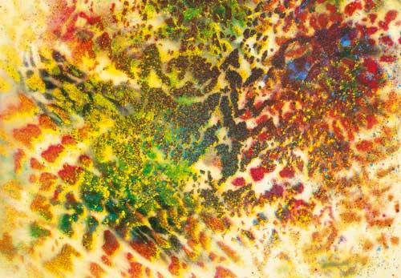
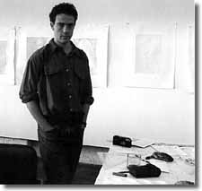
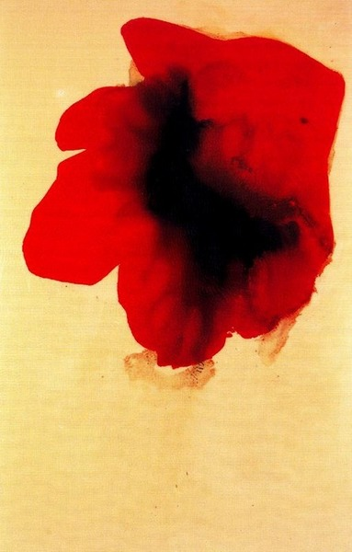
Left: Soller, Right: Eclipses

Big Ideas
- Identity
- Expression
- Nature
- Color
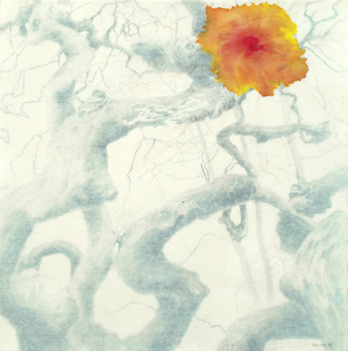
Lesson Ideas:
Identity: Sicilia claims to paint the feeling that objects give you rather than the object themselves. Students can explore their own identity but creating an image of their personality rather than their physical selves. They can be encouraged to use expressive line and color to create an abstract image or a realistic image. This will force the students to explore themselves.
Expression: It has been stated that Sicilia has a style that combines expressionism with modern art. He uses expressive line and color to give his works expression. Students can be instructed to use expressive line and color to create an original piece of work based in Sicilia’s work as well as classic expressionism.
Nature: A lot of Sicilia’s work is based on not only the physical aspects of nature but also the feel of nature. Students can take this opportunity to do some observational work while still experimenting with color.

Resources

Meessen De Clercq- A gallery in Brussels, Belgium designed for bringing international artist together.
http://www.meessendeclercq.be/artists/jose-maria-sicilia/text

Frieze Magazine Issue 59 from May 2001. Online Archive:
http://www.frieze.com/issue/review/jose_maria_sicilia/

Contemporary Art: A Daily Journal of International Exhibitions
http://www.contemporaryartdaily.com/2010/02/jose-maria-sicilia-at-chantal-crousel/

Books:

Jose Maria Sicilia: Shadow Play (1990 Catalogue, NY)

Jose Maria Sicilia: Pinturas 1983-84. Vijande, Fernando

5 Artistas Espanolas: Spanish Artists. Artists Space, 223 West Broadway New York, NY

